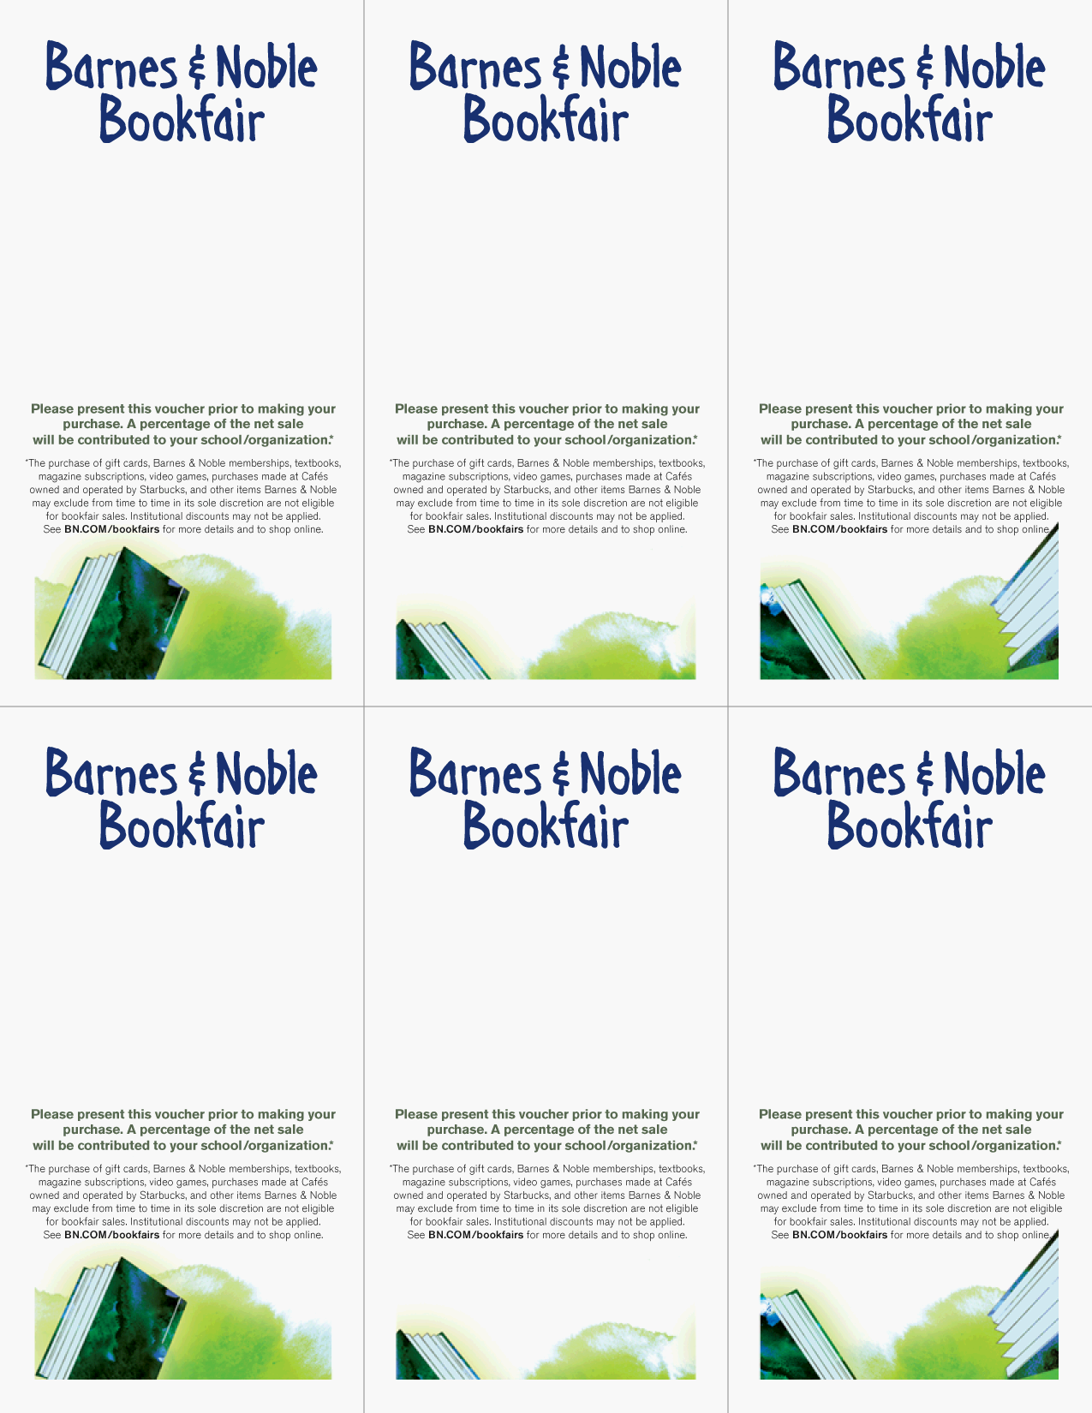
supporting
Steller Secondary School
Name
Saturday, October 2, 9 am- 11 pm

Barnes & Noble
200 East Northern Lights Blvd.

Bookfair ID 10300259
supporting
Steller Secondary School
Name
Saturday, October 2, 9 am- 11 pm

Barnes & Noble
200 East Northern Lights Blvd.

Bookfair ID 10300259
supporting
Steller Secondary School
Name
Saturday, October 2, 9 am- 11 pm

Barnes & Noble
200 East Northern Lights Blvd.

Bookfair ID 10300259
supporting
Steller Secondary School
Name
Saturday, October 2, 9 am- 11 pm

Barnes & Noble
200 East Northern Lights Blvd.

Bookfair ID 10300259
supporting
Steller Secondary School
Name
Saturday, October 2, 9 am- 11 pm

Barnes & Noble
200 East Northern Lights Blvd.

Bookfair ID 10300259
supporting
Steller Secondary School
Name
Saturday, October 2, 9 am – 11 pm

Barnes & Noble
200 East Northern Lights Blvd.

Bookfair ID 10300259

