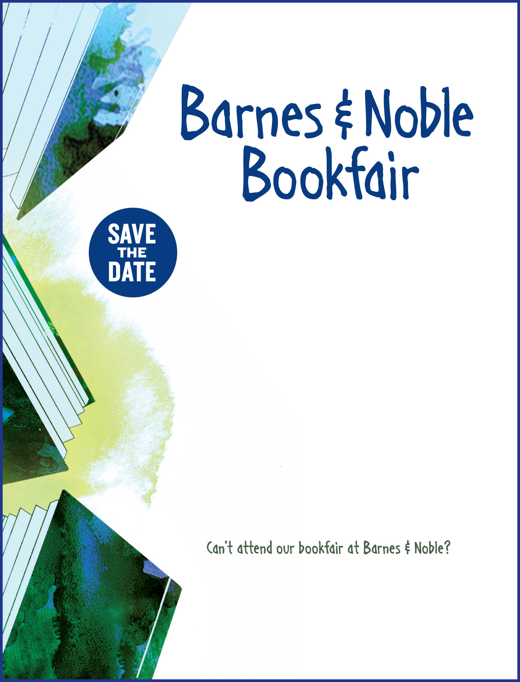
Steller Secondary School
Saturday, October 2, 2010
9 am – 11 pm
Barnes & Noble
200 East Northern Lights

Banned Books Read-Out
1:00 pm – 3:00 p.m.

Visit bn.com/bookfairs to support us online
from 10/2/10 to 10/5/10
by entering Bookfair ID 10300259 at checkout.

A percentage of your Barnes & Noble purchases
will benefit our school!

